SISTERHOOD CALENDAR

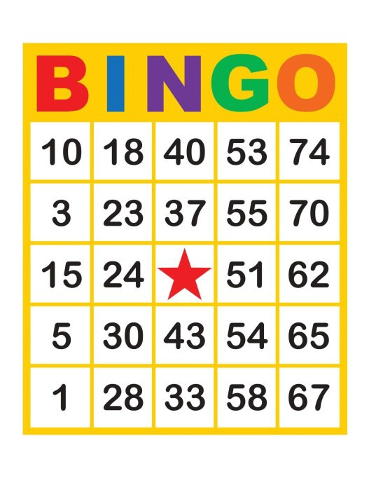

2024-2025 (5785)

**Calendar is subject**

**to change.**

|  |  |  |  |  |  |  |
| --- | --- | --- | --- | --- | --- | --- |
| **SEPTEMBER 2024** | | | | | | |
|  | | | | | | |
| SUNDAY | MONDAY | TUESDAY | WEDNESDAY | THURSDAY | FRIDAY | SATURDAY |
| **1** | **2** | **3** | **4**  **Sisterhood**  **Meeting 7:30 PM** | **5** | **6** | **7** |
| **8** | **9**  **YOGA - 7 PM** | **10** | **11** | **12** | **13** | **14** |
| **15** | **16** | **17** | **18**  **BINGO IN**  **PERSON** | **19** | **20** | **21** |
| **22** | **23**  **ISRAELI DANCING— 7:30 PM** | **24** | **25** | **26** | **27** | **28** |
| **29** | **30** |  |  |  |  |  |

|  |  |  |  |  |  |  |
| --- | --- | --- | --- | --- | --- | --- |
| **OCTOBER 2024** | | | | | | |
| SUNDAY | MONDAY | TUESDAY | WEDNESDAY | THURSDAY | FRIDAY | SATURDAY |
|  |  | **1** | **2**  **Erev Rosh Hashanah** | **3** | **4** | **5** |
| **6** | **7** | **8** | **9**  **Sisterhood**  **Meeting**  **7:30 PM** | **10** | **11**  **Erev Yom**  **Kippur** | **12** |
| **13** | **14** | **15** | **16** | **17** | **18** | **19** |
| **20** | **21** | **22** | **23**  **SISTERHOOD DINNER IN THE SUKKAH** | **24** | **25** | **26** |
| **27** | **28** | **29** | **30** | **31** |  |  |

|  |  |  |  |  |  |  |
| --- | --- | --- | --- | --- | --- | --- |
| **NOVEMBER 2024** | | | | | | |
| SUNDAY | MONDAY | TUESDAY | WEDNESDAY | THURSDAY | FRIDAY | SATURDAY |
|  |  |  |  |  | **1** | **2** |
| **3** | **4** | **5** | **6**  **Kristallnacht** | **7** | **8** | **9** |
| **10** | **11** | **12** | **13**  **Sisterhood Meeting**  **7:30 PM** | **14** | **15** | **16** |
| **17**  **GARAGE SALE**  **&**  **FLEA MARKET** | **18** | **19** | **20** | **21** | **22** | **23** |
| **24** | **25** | **26** | **27** | **28** | **29** | **30** |

|  |  |  |  |  |  |  |
| --- | --- | --- | --- | --- | --- | --- |
| **DECEMBER 2024** | | | | | | |
|  | | | | | | |
| SUNDAY | MONDAY | TUESDAY | WEDNESDAY | THURSDAY | FRIDAY | SATURDAY |
| **1** | **2** | **3** | **4**  **Sisterhood Meeting 7:30 PM**  **Chanukah Grab Bag** | **5** | **6** | **7** |
| **8** | **9** | **10** | **11** | **12** | **13** | **14** |
| **15** | **16** | **17** | **18**  **Card & Game**  **Party** | **19** | **20** | **21** |
| **22** | **23** | **24** | **25**  **1st Night Chanukah** | **26** | **27** | **28** |
| **29** | **30** | **31** |  |  |  |  |
|  |  |  |  |  |  |  |

**JANUARY 2025**

|  |  |  |  |  |  |  |
| --- | --- | --- | --- | --- | --- | --- |
| SUNDAY | MONDAY | TUESDAY | WEDNESDAY | THURSDAY | FRIDAY | SATURDAY |
|  |  |  | **1** | **2**  **Chanukah Last Day** | **3** | **4** |
| **5** | **6** | **7** | **8**  **Sisterhood Meeting 7:30 PM** | **9** | **10** | **11** |
| **12** | **13** | **14** | **15** | **16** | **17** | **18** |
| **19** | **20**  **MARTIN LUTHER KING DAY** | **21** | **22**  **ZOOM BINGO** | **23** | **24** | **25** |
| **26** | **27** | **28** | **29** | **30** | **31** |  |

**FEBRUARY 2025**

|  |  |  |  |  |  |  |
| --- | --- | --- | --- | --- | --- | --- |
| SUNDAY | MONDAY | TUESDAY | WEDNESDAY | THURSDAY | FRIDAY | SATURDAY |
|  |  |  |  |  |  | **1** |
| **2** | **3** | **4** | **5 Sisterhood**  **Meeting 7:30 PM** | **6** | **7** | **8** |
| **9** | **10** | **11** | **12** | **13** | **14** | **15** |
| **16** | **17** | **18** | **19**  **Paint & Sip** | **20** | **21** | **22** |
| **23** | **24** | **25** | **26** | **27** | **28** |  |

|  |  |  |  |  |  |  |
| --- | --- | --- | --- | --- | --- | --- |
| **MARCH 2024** | | | | | | |
| SUNDAY | MONDAY | TUESDAY | WEDNESDAY | THURSDAY | FRIDAY | SATURDAY |
|  |  |  |  |  |  | **1** |
| **2** | **3** | **4** | **5 Sisterhood**  **Meeting 7:30 PM** | **6** | **7**  **Shabbat Across America ??** | **8** |
| **9** | **10** | **11** | **12** | **13**  **Erev Purim** | **14**  **Purim** | **15** |
| **16** | **17** | **18** | **19** | **20** | **21** | **22** |
| **23** | **24** | **25** | **26** | **27** | **28** | **29** |
| **30** | **31** |  |  |  |  |  |

|  |  |  |  |  |  |  |
| --- | --- | --- | --- | --- | --- | --- |
| **APRIL 2024** | | | | | | |
| SUNDAY | MONDAY | TUESDAY | WEDNESDAY | THURSDAY | FRIDAY | SATURDAY |
|  |  | **1** | **2**  **Sisterhood Meeting 7:30 PM** | **3** | **4** | **5** |
| **6** | **7** | **8** | **9** | **10** | **11** | **12**  **Erev Passover** |
| **13** | **14** | **15** | **16** | **17** | **18** | **19** |
| **20**  **Last Day of**  **Passover** | **21** | **22** | **23**  **Yom Hashoah**  **Program** | **24** | **25** | **26** |
| **27** | **28** | **29** | **30**  **Yom Ha’atzmaut Celebration** |  |  |  |

|  |  |  |  |  |  |  |
| --- | --- | --- | --- | --- | --- | --- |
| **MAY 2024** | | | | | | |
| SUNDAY | MONDAY | TUESDAY | WEDNESDAY | THURSDAY | FRIDAY | SATURDAY |
|  |  |  |  | **1** | **2**  **Sisterhood**  **Shabbat Weekend** | **3**  **Sisterhood Shabbat Weekend** |
| **4** | **5** | **6** | **7**  **Sisterhood Meeting 7:30 PM** | **8** | **9** | **10** |
| **11** | **12** | **13** | **14** | **15** | **16**  **Lag Ba’Omer** | **17** |
| **18** | **19**  **Frozen Planet**  **Fundraiser** | **20** | **21** | **22** | **23** | **24** |
| **25** | **26** | **27** | **28** | **29** | **30** | **31** |

**JUNE 2024**

|  |  |  |  |  |  |  |
| --- | --- | --- | --- | --- | --- | --- |
| SUNDAY | MONDAY | TUESDAY | WEDNESDAY | THURSDAY | FRIDAY | SATURDAY |
| **1**  **Erev Shavuot** | **2**  **Shavuot** | **3**  **Shavuot** | **4**  **Sisterhood**  **Meeting** | **5** | **6** | **7** |
| **8** | **9** | **10** | **11** | **12** | **13** | **14** |
| **15** | **16** | **17** | **18**  **End of Year Dinner** | **19** | **20** | **21** |
| **22** | **23** | **24** | **25** | **26** | **27** | **28** |
| **29** | **30** |  |  |  |  |  |
|  |  |  |  |  |  |  |